Landscape photography:
The primary thing that appeals to me in landscape photography is the freedom for complex scenes with clearly defined objects of interest, as well as focal points and larger-scale visual effects. For instance, the second image employs contrast to draw attention to a certain area.

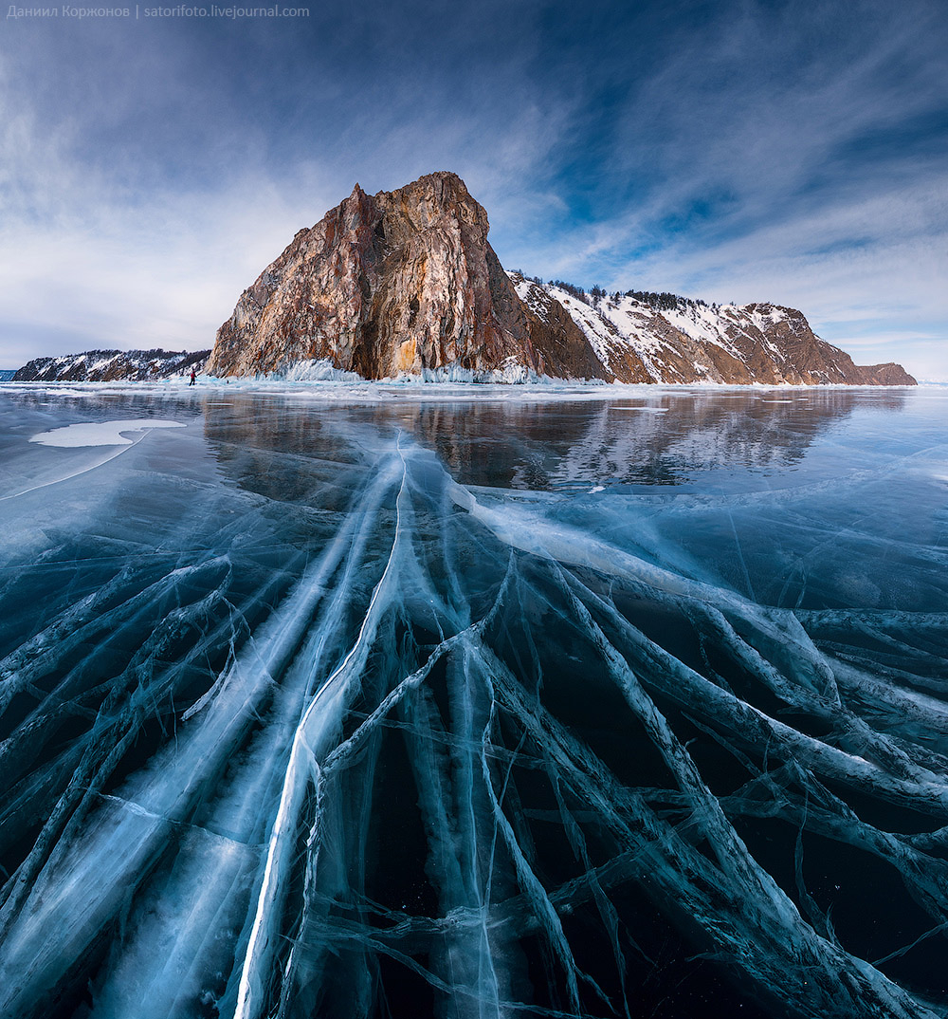
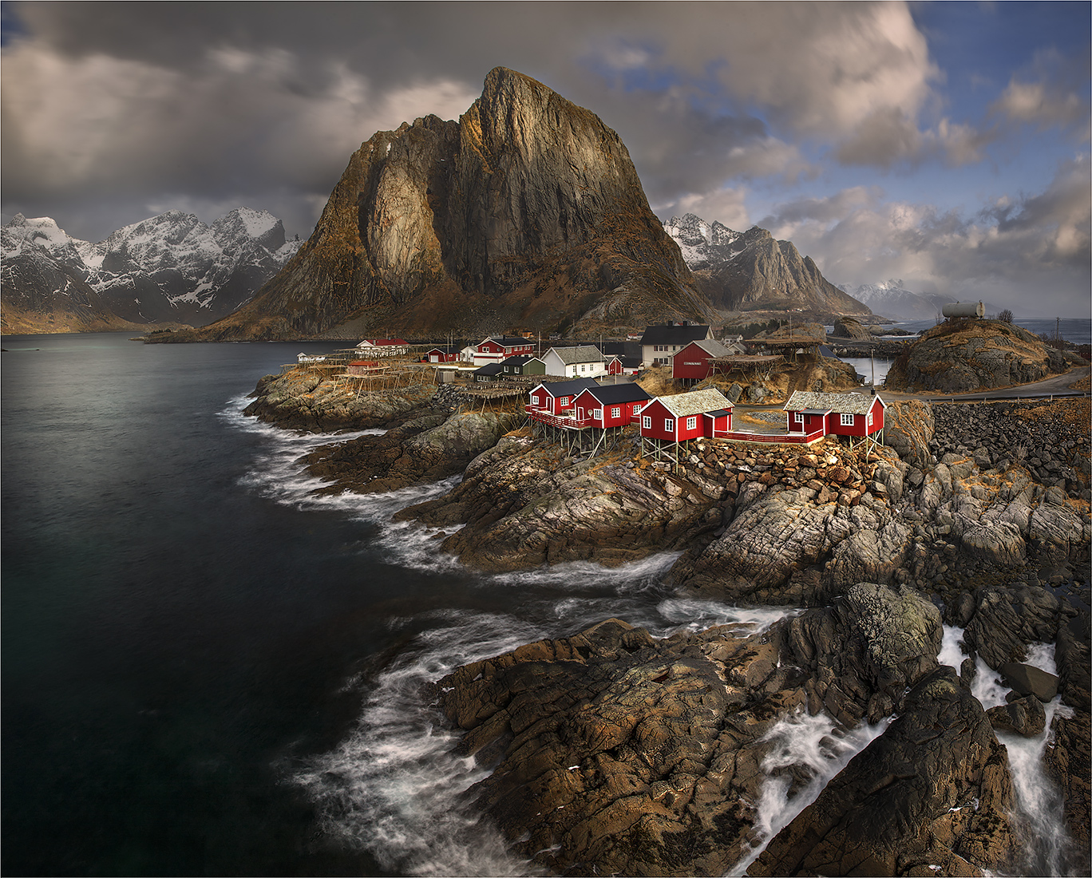

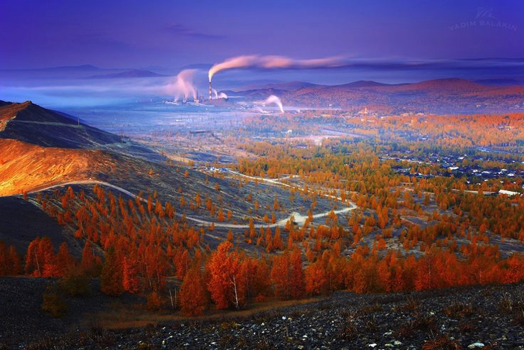

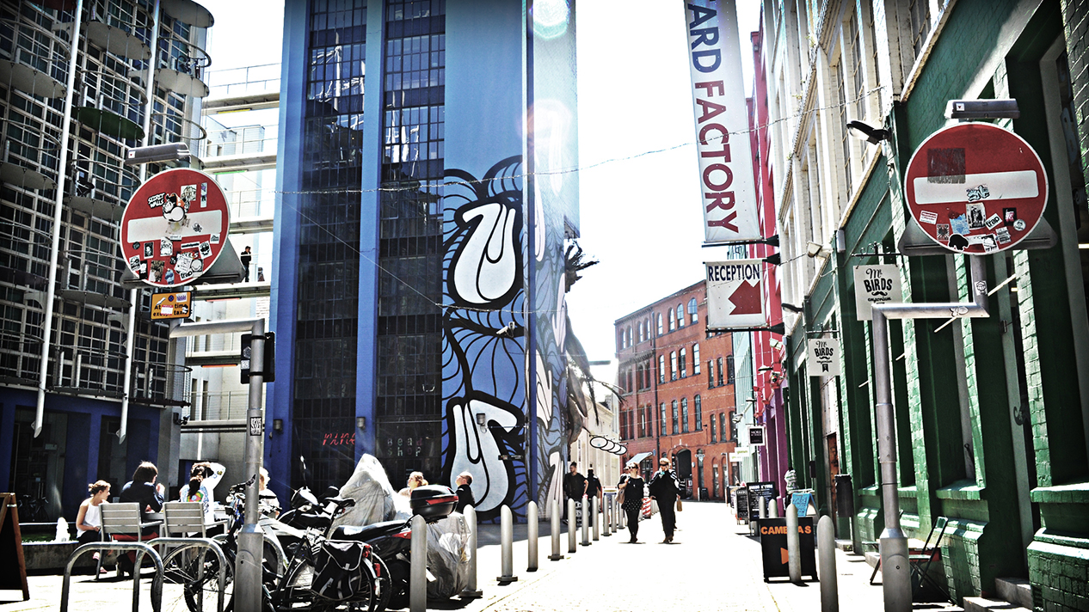
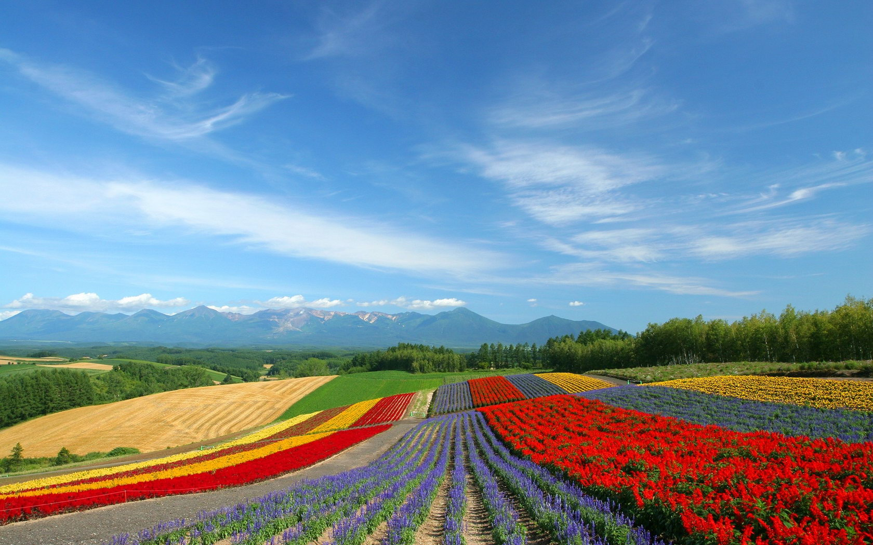

HDR Photography:
HDR is a really interesting effect, and can be used to make some amazing photos. Unfortunately, only about one in a hundred photos even begin to appropriately use this effect. The rest all completely and utterly ruin the photos with an overdone HDR effect, producing an unpleasing, painful image.
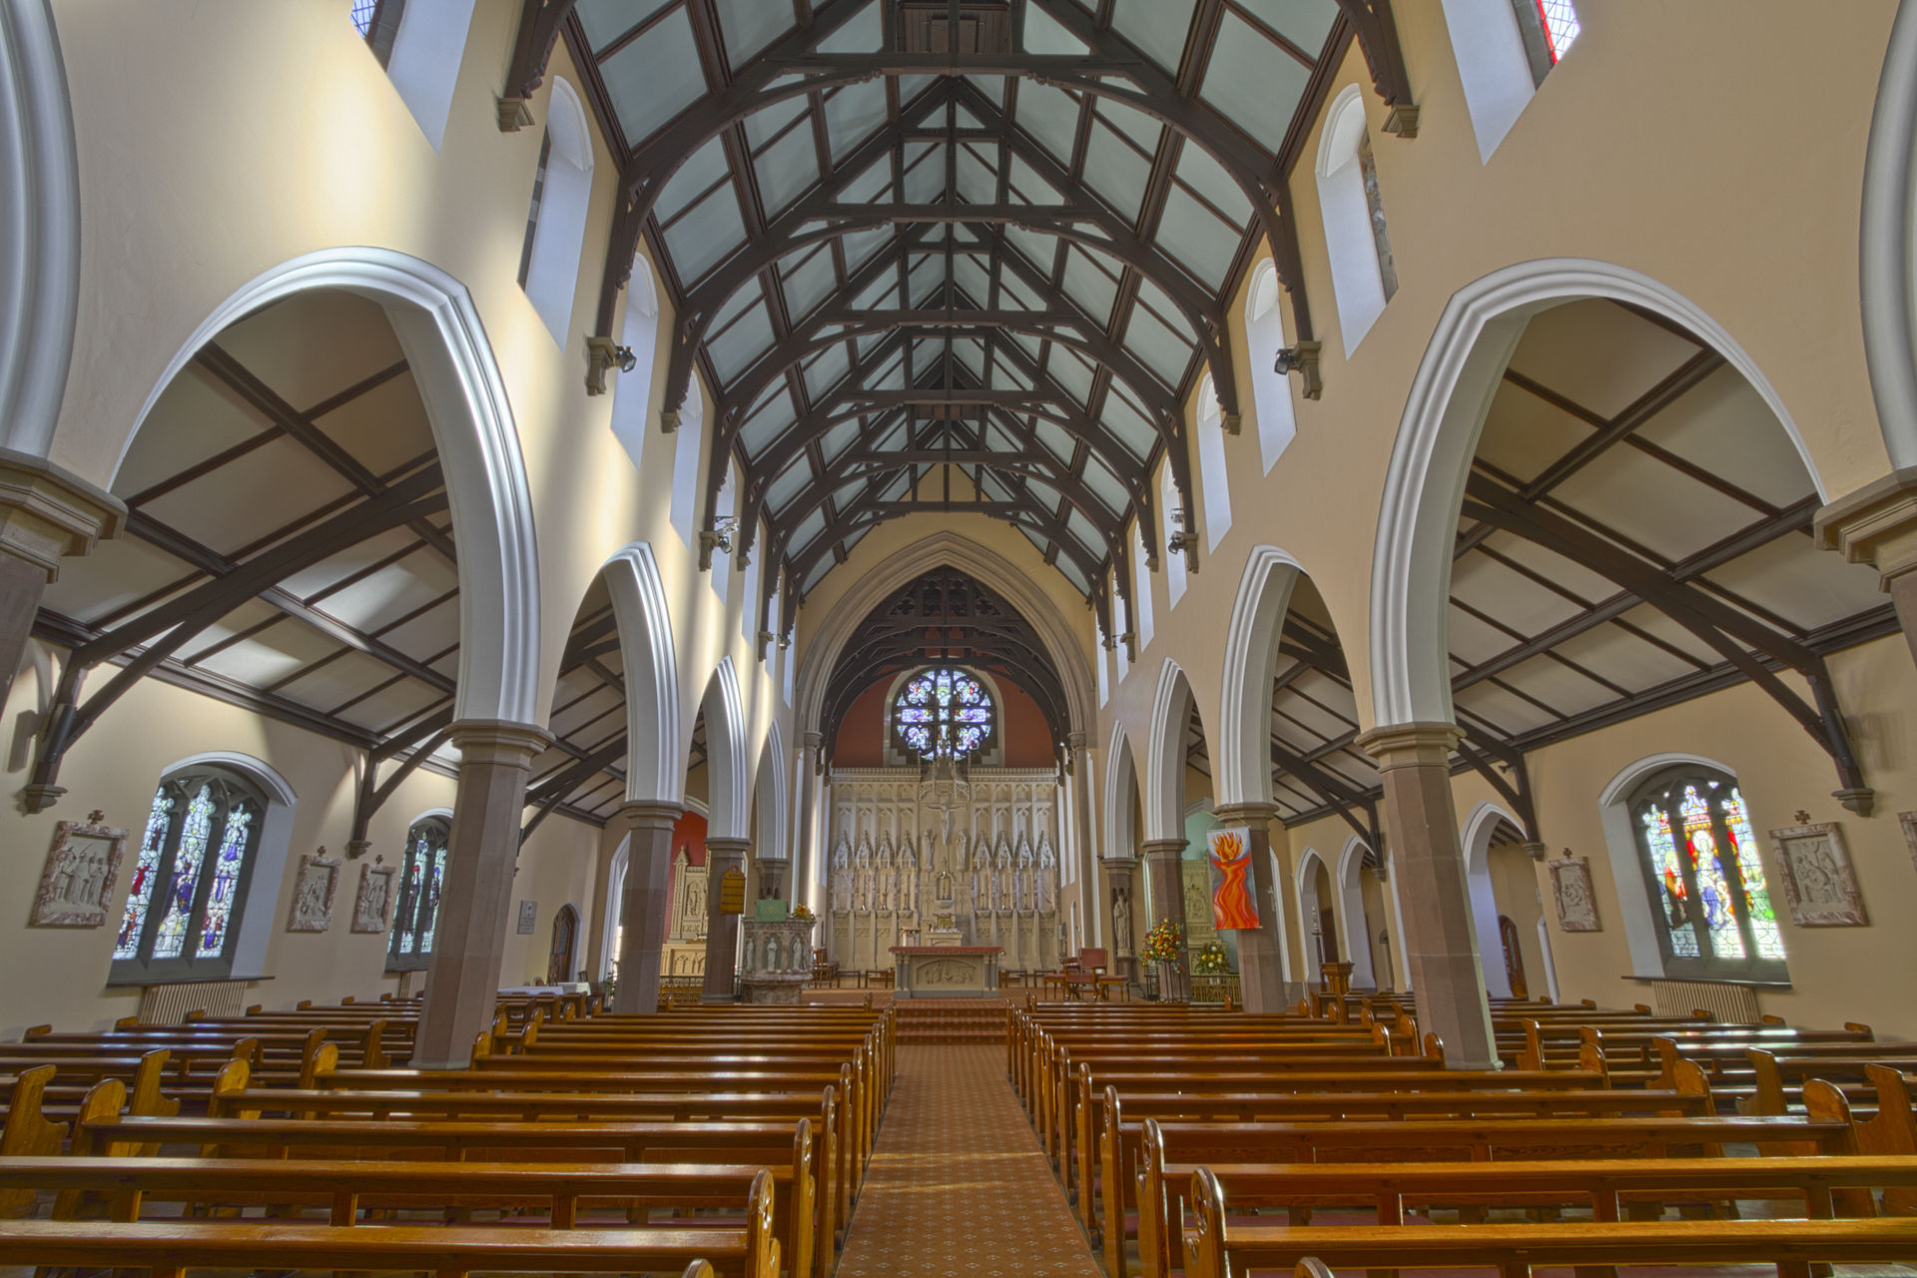

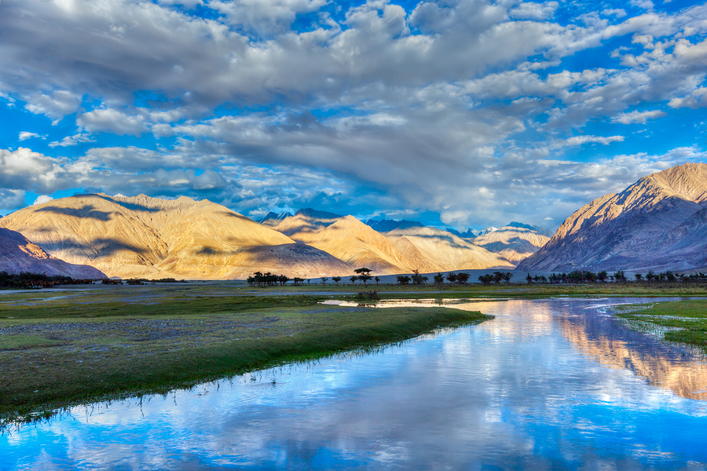

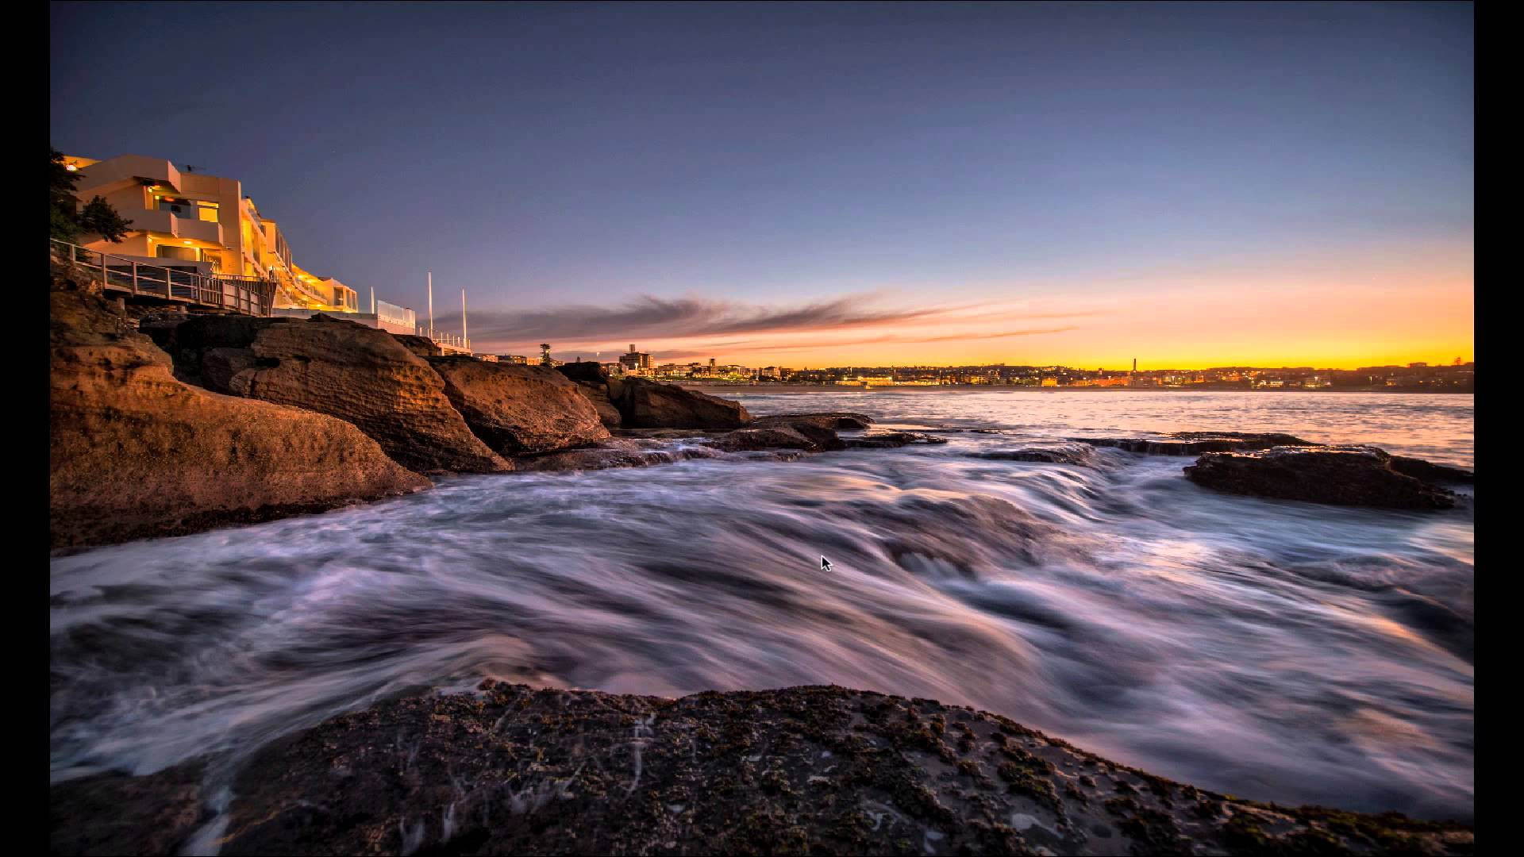

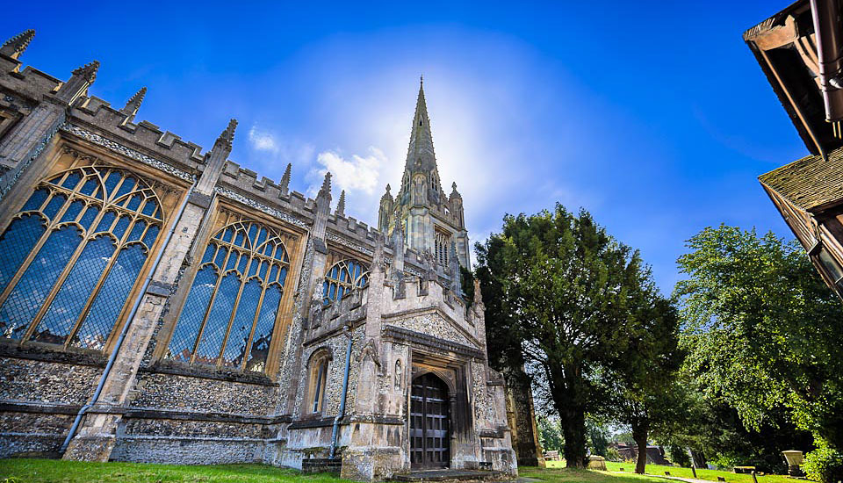

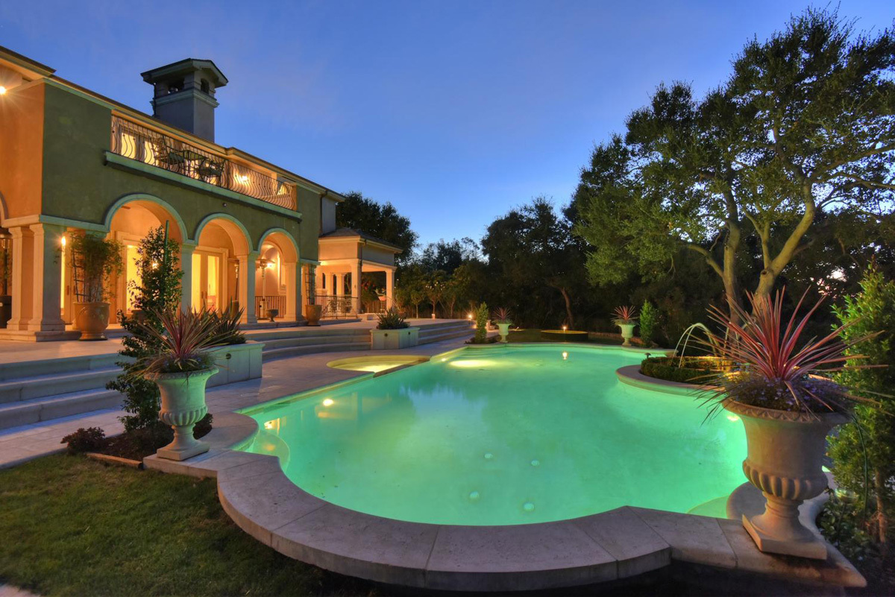
Portrait photography:
Portrait photography is certainly interesting in how it allows one to capture the essence or character of the subject (not necessarily human). However, what I personally find more appealing is what it allows one to do with the background, lighting, and color theming.

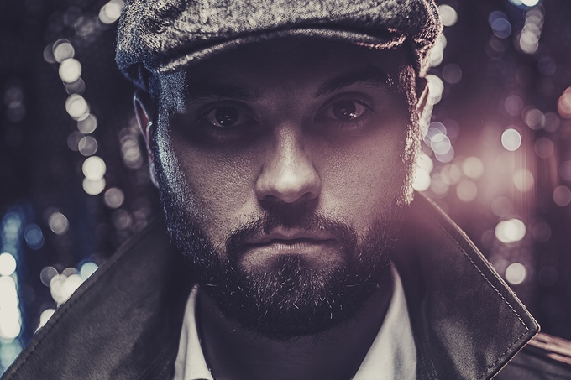
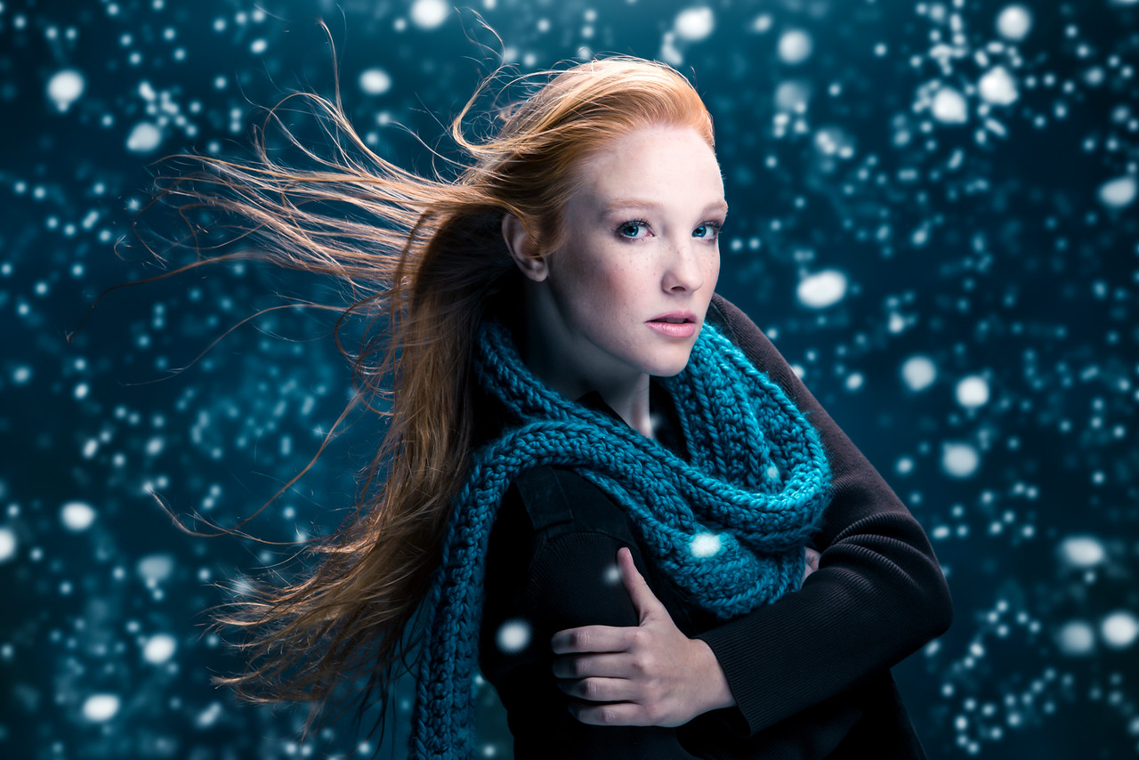

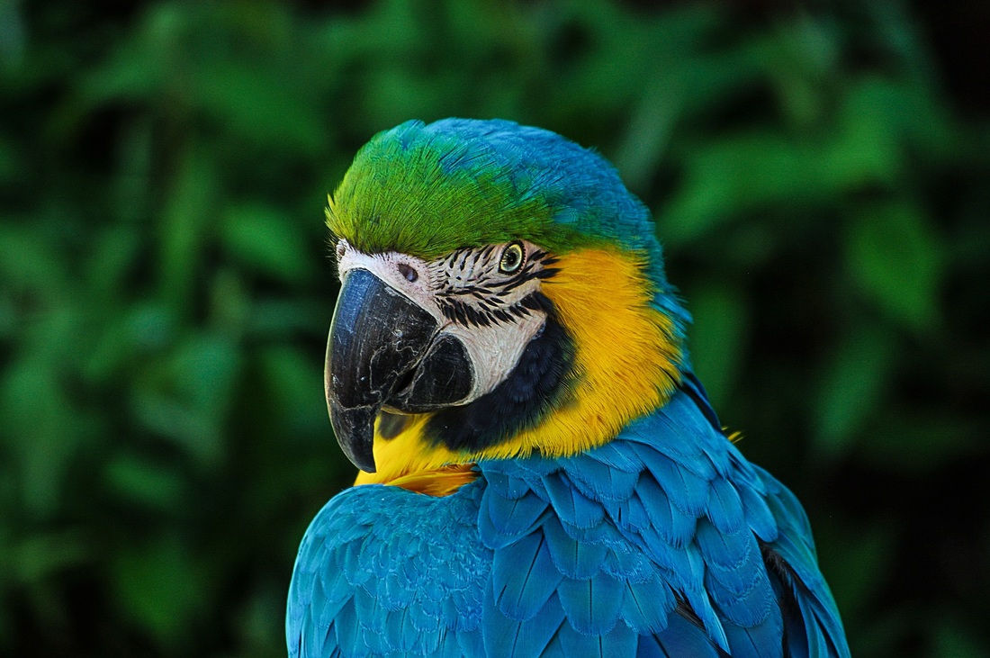

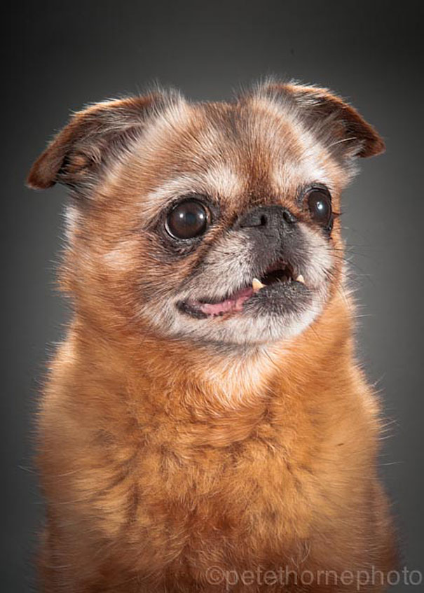

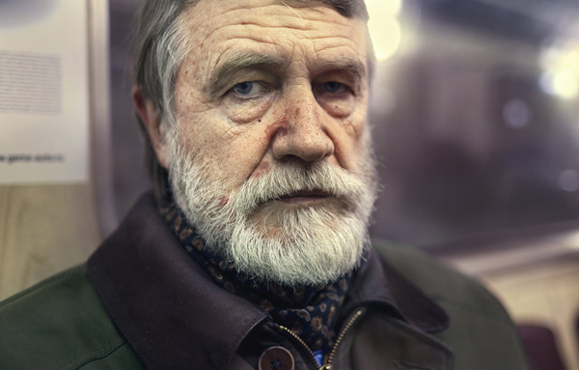

Macro photography:
Macro photography is easily one of my more favorite types of photography. It allows one to clearly define a small subset of objects as the objects of interest in a photo, and focuses on the material qualities (texture, color, etc) of that one object rather than the overall scene.



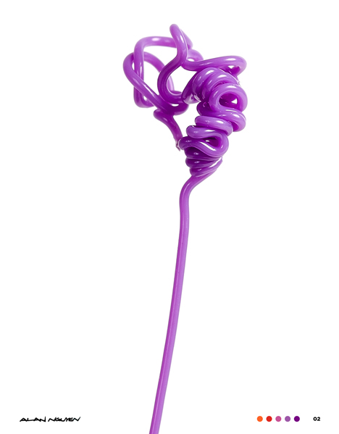

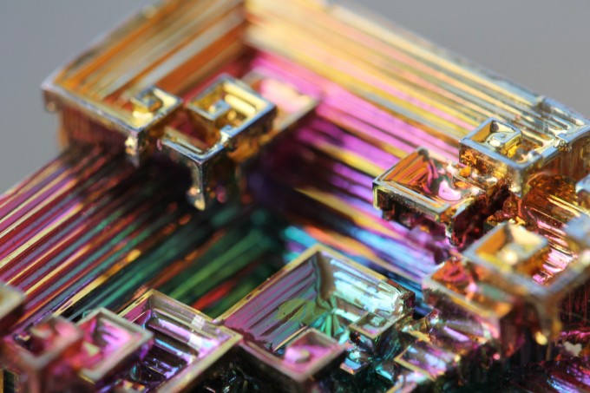

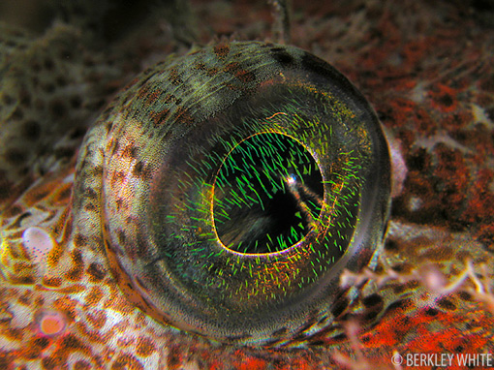

Surreal photography:
It’s certainly interesting, but not my absolute favorite. A lot of times, there’s lazy or lower quality camera work, with a lot of people using the surrealist nature as a crutch.


